Dear Choir Students and Parents/Legal Guardians,
My name is Elena Hutchinson, I am a second grade teacher at Donald D. Stalker Elementary School and this year I will be our school’s choir director. I am looking forward to a wonderful year of music-making and learning. Thank you for sharing your student with me!

Choir is a lot of fun! And it also develops students into productive citizens. The discipline of music requires goal setting, concentrating, individual responsibility, teamwork, quick decision making, and thriving under pressure. Productive citizens retain these skills and use them in life. Success in our program leads to success in life.

I truly believe your student can earn a feeling of joy and accomplishment in choir. Let’s have a fantastic year in which your student develops through musical excellence!

When/Where
Choir will take place on Thursday afternoons during the school day, between 2:15 & 3:00 PM in the music room. Students wishing to participate must review this contract agreement with their families and return it signed to school. They may turn them in to their classroom teacher, who will in turn place it in my teacher mailbox by the office.

As this year is our inaugural year of choir, we are breaking up commitment to choir into three sessions:
- September 21st through Veterans Day will be our first session.
- Second session will start after our Veterans Day concert and run until our Christmas program, within the first two weeks of December.
- Third session will begin January 18th and run through mid-April, when we will have our final performance. Our spring performance date is TBD.

At the beginning of each session, I will re-issue new student and parent contract agreements for you and your student to sign and return.

What is the choir singing this year?
We will perform two patriotic songs during our school’s Veterans Day assembly, one choir-exclusive Christmas song during our school’s Christmas Program, and four secular pieces of music in the springtime at our spring concert, again the date is TBD.

Which students are eligible to join?
Choir will be open to students in grades 3-5 in our first session. We will then open it up K-5 for our second and third sessions, after allowing the rest of the school and our younger grades to see us perform for Veterans day.

Discipline
The foundation of any superior organization is superior discipline. Singers must take responsibility for their actions and engage in self-discipline. The rules presented in the Blackfoot School District Discipline Policy Handbook will also apply in rehearsal and during performances.

Classroom Rules
- Be on time. 2. Be respectful. 3. Be responsible. 4. Be attentive. 5. Be a leader.

Procedures
Entering the choir room:
- Enter the room quietly.
- Place backpack/any belongings in designated area, obtain folder and pencil, and immediately go to assigned seat.
- Be in your assigned seat before Mrs. Hutchinson’s class timer rings.
- Have only a folder and a pencil at your seat.

During class:
- No food, drink, gum, or candy is allowed. Water only. Bottled water will be allowed to be brought in and placed on the floor under your seat.
- No electronic device is allowed (heard or seen)
- No talking during rehearsal time. Questions are absolutely essential to music learning, so raise your hand to speak.
- Be attentive, watch your teacher, and actively participate.
- Remain in your assigned seat face-forward, hands to yourself, and feet on the floor at all times, unless directed otherwise.
We will be moving a lot during rehearsal, standing and sitting, using sign language and body percussion, as well as playing rhythmic, note-name, and singing games. Activities will go quickly and students will need to be ready for quick change.

Exiting the choir room:
- Wait for Mrs. Hutchinson to dismiss you.
- Return folders, pencils, and gather your things. (*folders must remain in the choir room. Additional copies will be sent home for review.)
- Walk, don’t run, and hold the door for the student behind as you leave, to ensure a safe exit of one child out at a time.
- Go out and be awesome!

Leaving during class:
- Use the restroom/get water before or after class. Students will only be allowed to leave the choir room during class for extreme circumstances.
- Make-up work or exams (for other classes) are not to be done during choir rehearsal.

Consequences
My teaching philosophy is that every child deserves a fresh start every day, and that everyone can sing. If you can talk, you can sing. Signing this contract shows me that you are willing to do your best in following my rules and procedures. Disruptive and disrespectful behavior will not be tolerated. However, these offenses will not roll over into the next rehearsal, and each child will get a fresh start each week.

Offense 1 - verbal warning
Offense 2 - verbal warning, behavior reflection paper issued (to be completed and returned)
Offense 3 - verbal warning, note home to parent/guardian (to be signed and returned)
Offense 4 - dismissal from choir, office referral

If four offenses occur in the same rehearsal, your child will not be allowed to return or participate in choir for the remainder of each choir session. If they wish to try again at the start of Session 2 or Session 3, they are welcome to do so, with a newly signed contract agreement.

Uniforms
Dress for any performance is as follows:

Boys | Black shoes (no tennis shoes)  Black socks  Black pants  Any solid-colored, long-sleeve,  button down shirt | Girls | Black shoes (no tennis shoes, no open toes)  Black hose or socks (no bare skin)  Black pants or black skirt, knee-length or longer  Any solid-colored, long-sleeve,  button down shirt or blouse
Stud earrings only - hair out of face

Communication

The following link is a class dojo page, Choir at Stalker Elementary, that will have updates, calendars, audio files, sheet music, lyrics, etc. regarding choir! Check it often!
https://www.classdojo.com/ul/p/addKid?target=class&class=CPPQZFF

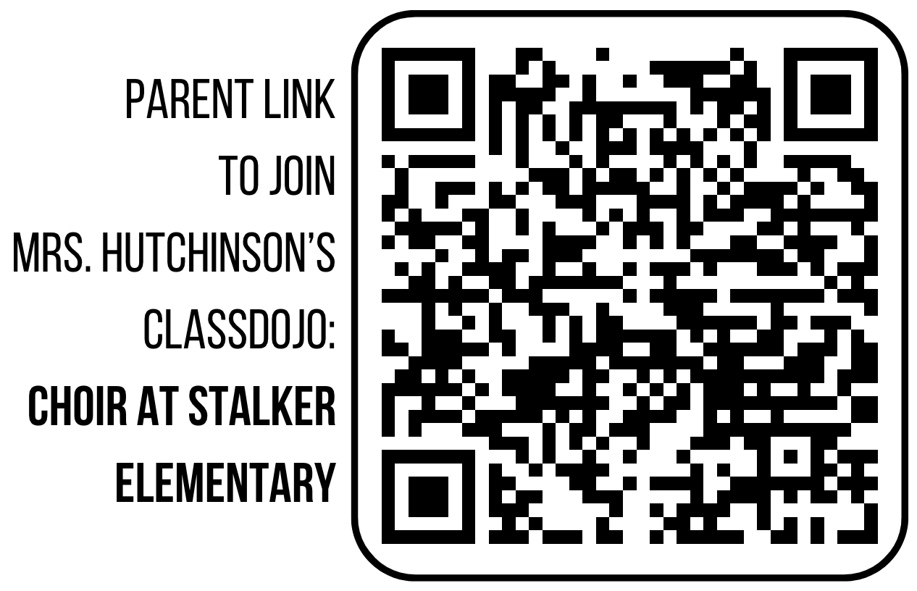
Instead of typing in the above link, scan this QR code to get to the same place - it will direct you to join my choir class dojo as a parent and add your student:

For any questions or concerns,
You are also welcome to email me at hutcelen@d55.k12.id.us at any time.

To allow your student to join choir, sign and return this page no later than Monday, September 25, 2023.

Choir Contract Agreement - Session 1

I/We, the undersigned, hereby grant ____________________________________________
permission to participate in this school-sponsored activity as a member of the Stalker Elementary Choir beginning September 21, 2023 and ending November 9, 2023.

I agree that I have received, read, and will follow the policies in the Stalker Elementary Choir Contract. I also agree that I will first contact Mrs. Hutchinson for questions or if there is a problem.

Student’s Name: ________________________________ _____________________________
(Please Print) (Signature)

Parent’s Name: _________________________________ _____________________________
(Please Print) (Signature)

Address: ___________________________________________________________________
(Street, City, State, Zip)

Parent/Guardian Email(s): _______________________________________________________

Student Phone (if applicable): ____________________________________________________

Parent/Guardian Phone(s): ______________________________________________________

